**CP PLUS Recognized as the Best Smart Security Brand 2024 by Gadgets 360 and NDTV**



In a resounding acknowledgment of its commitment to innovation and excellence in the security industry, CP PLUS has been awarded the prestigious title of "Best Smart Security Brand 2024" by Gadgets 360 and NDTV. This accolade reaffirms CP PLUS's position as a global leader in cutting-edge security solutions, setting new benchmarks for smart surveillance technology.

Gadgets 360 and NDTV, two of India's most respected technology and media platforms, conducted extensive research and analysis to identify the most outstanding brands across various categories. CP PLUS emerged as the undisputed winner in the Smart Security segment, showcasing its unparalleled expertise and unwavering dedication to providing advanced security solutions for homes, businesses, and communities.

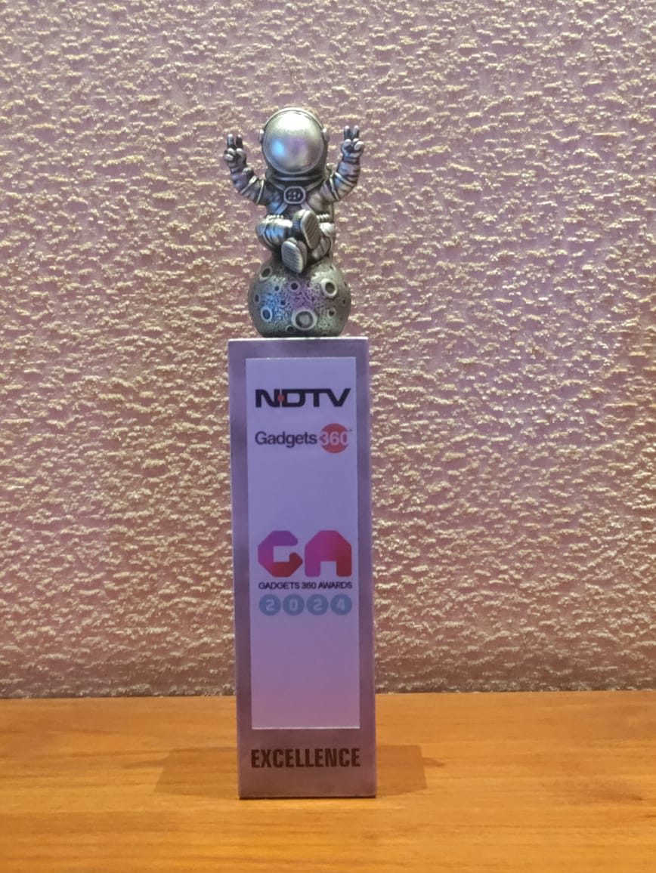

With an unwavering commitment to innovation, CP PLUS has continuously pushed the boundaries of what's possible in the security industry. From state-of-the-art CCTV cameras to intelligent video analytics and cloud-based surveillance systems, CP PLUS offers a comprehensive suite of products and services designed to meet the evolving needs of modern security challenges.

"We are deeply honored to receive this prestigious award from Gadgets 360 and NDTV," said Mr. Sanjay Gogia, President - CP PLUS. "This recognition is a testament to our relentless pursuit of excellence and our commitment to delivering innovative security solutions that empower our customers to protect what matters most to them."

The award highlights CP PLUS's significant contributions to the advancement of smart security technologies, including:

This Award is a testament to CP PLUS' strengthening impact, recognizing the company's commitment to pushing the boundaries of innovation and excellence in every vertical. CP PLUS has consistently demonstrated its prowess in developing advanced security solutions that cater to the evolving needs of both homes and industries, setting a benchmark for others to follow.

The award ceremony highlighted CP PLUS' remarkable contributions to the field of security and surveillance, showcasing the company's ability to adapt to changing landscapes and deliver solutions that meet the highest standards. CP PLUS' dedication to shaping a safer future resonated with the ethos of Gadgets 360, which celebrates organizations that not only excel in their respective fields but also contribute significantly to the tech revolution in India.

About CP PLUS:

CP PLUS is a globally recognized leader in advanced security solutions, offering a comprehensive portfolio of surveillance products and services designed to safeguard homes, businesses, and communities. With a focus on innovation, quality, and customer satisfaction, CP PLUS is committed to delivering cutting-edge security solutions that meet the evolving needs of modern security challenges. For more information, visit [www.cpplusworld.com](http://www.cpplusworld.com/).