**CP PLUS Revolutionizes Remote Surveillance with Solar-Powered AI-Enabled 4G Cameras**

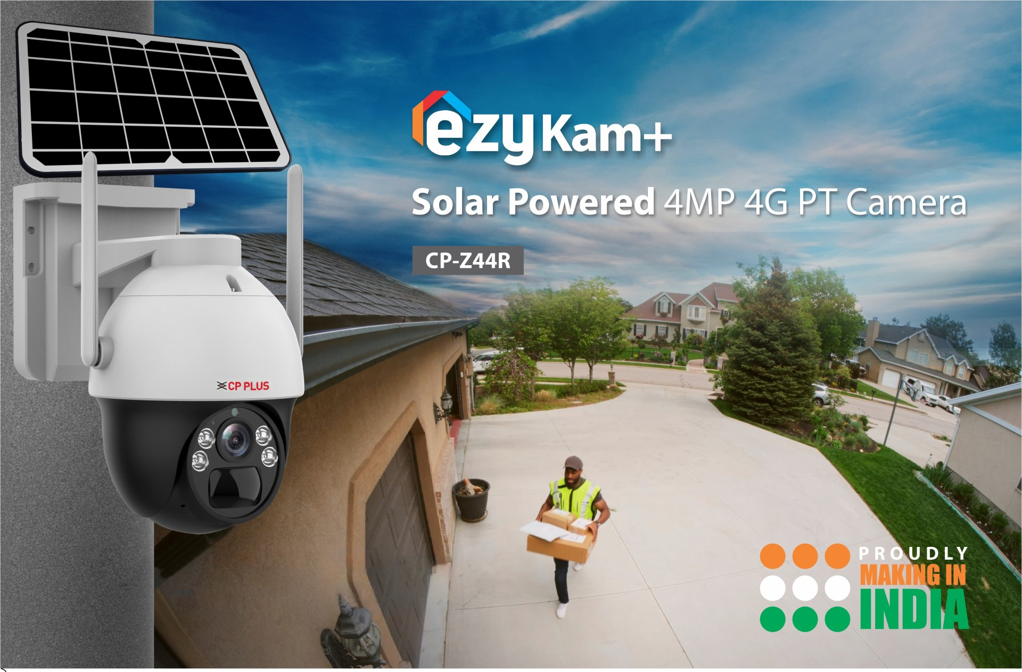

CP PLUS, a global leader in advanced security solutions, is proud to announce the launch of its groundbreaking line of Solar-Powered AI-enabled leading-edge 4G Cameras. Designed to set new standards in security, these cutting-edge cameras combine the power of solar technology, artificial intelligence, and unparalleled features to ensure optimal protection for homes and businesses.

As India continues to embrace digitization and smart technologies, CP PLUS remains unwavering in its mission to make these innovations accessible and effective in safeguarding lives and assets. The brand's relentless pursuit of emerging technologies ensures that the Indian market stays well-equipped to meet the challenges of an ever-evolving security landscape, making CP PLUS a trusted partner in securing the nation's future.

Moreover, this new series of leading-edge cameras, recently launched by CP PLUS, make a breakthrough with 4G SIM support. This means that these cameras do not depend on wires or Wi-Fi as they have an integrated SIM slot that supports 4G SIM cards to present a highly dependable stand-alone solution to users situated at remote locations.

Key Features of CP PLUS Solar-Powered AI-Enabled Leading-Edge Cameras:

* Solar-Powered 4MP PT Camera with 7W Solar Panel:
  + Harnesses the sun's energy to provide continuous surveillance, reducing the need for external power sources.
  + Environmentally friendly and cost-effective.
* 4G LTE Support:
  + Ensures seamless connectivity, enabling real-time monitoring and remote access from anywhere in the world.
* In-built Battery:
  + Offers backup power in the event of cloudy days or power outages, ensuring uninterrupted surveillance.
* Full-Color Camera:
  + Provides full-color video even in low light conditions, illuminating darker areas with perfect clarity using spotlights.
  + Captures details with exceptional precision, enhancing security.
* Human Body Detection:
  + Effectively detects human movements and sends real-time alerts to reduce false alarms.
  + Ensures that you are alerted only when it matters most.
* Motion Tracking:
  + Automatically tracks movement within the video frame by rotating on its own.
  + Keeps a vigilant eye on potential threats, following their every move.
* In-built PIR Sensor:
  + Detects movement within the video frame and sends alerts in real-time.
  + Enhances security by identifying potential intrusions.
* 256GB SD Card Support:
  + Offers ample storage space for recorded footage, allowing you to review events at your convenience.
* In-built Siren:
  + Acts as a powerful deterrent by triggering a siren in response to suspicious activity.
  + Adds an extra layer of protection to your property.

With the launch of these Solar-Powered AI-enabled leading-edge 4G Cameras, CP PLUS is once again at the forefront of innovation in the security industry. These cameras are not just cutting-edge; they are a testament to the brand’s commitment to providing advanced, eco-friendly, and highly effective security solutions to its customers across the globe.

CP PLUS has been instrumental in ushering in a new era of security in the Indian market by consistently introducing and integrating emerging technologies. With a visionary approach, the brand has not only empowered businesses and homeowners with cutting-edge solutions but has also contributed to India's technological advancement.

From AI-enabled cameras that enhance surveillance precision to solar-powered systems that promote sustainability, CP PLUS has been at the forefront of innovation, delivering solutions that cater to the evolving needs of the Indian market. This commitment to embracing and implementing the latest technologies underscores CP PLUS's dedication to providing customers with state-of-the-art security solutions that redefine industry standards.

CP PLUS Solar-Powered 4G Cameras are ideal for a wide range of applications, including residential properties, commercial establishments, and remote locations. They offer a comprehensive solution that combines sustainability, convenience, and top-tier security.