**CP PLUS Launches Memory Card-Enabled IoT Cameras under EzyKam - Elevating Smart Surveillance to New Heights**

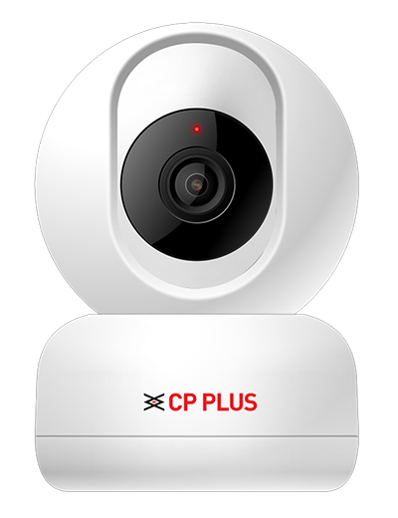

CP PLUS, a pioneering leader in security and surveillance solutions, has once again demonstrated its commitment to innovation with the introduction of memory card support for its flagship ioT camera range, EzyKam. This latest enhancement is a testament to CP PLUS's unwavering dedication to providing cutting-edge security solutions that cater to the evolving needs of homeowners and businesses in India and beyond.

CP PLUS is a globally renowned leader in security and surveillance solutions, dedicated to delivering cutting-edge technology and exceptional customer service. With a strong commitment to innovation, CP PLUS continues to redefine the security industry with its state-of-the-art products and solutions.

EzyKam, renowned for its high-definition quality and seamless integration with Ok-Google and Alexa, has now taken a giant leap forward by offering memory card support in two of its leading-edge models, CP-E26AM and CP-E36AM. This development enhances the efficiency and reliability of surveillance, addressing a long-standing challenge in the industry.

"CP PLUS is a brand synonymous with innovation and customer-centric solutions. Our introduction of memory card support for EzyKam is a game-changer in the world of smart surveillance," said Mr. Aditya Khemka, Managing Director, CP PLUS. "We understand the importance of seamless and reliable security, and this enhancement is a testament to our commitment for making smart surveillance accessible and dependable for all."

Designed to prevent data loss and ensure uninterrupted recording with memory card support, EzyKam streamlines the surveillance experience, eliminating the need for external storage devices. EzyKam also delivers high-quality images and records audio, providing a comprehensive view of your surroundings. Every detail is captured with precision, ensuring no aspect goes unnoticed.

Advanced motion detection algorithms enable automatic target detection and tracking, making it ideal for various applications, from traffic management to home security. EzyKam also employs cutting-edge facial recognition powered by artificial intelligence, enhancing security and offering an increased level of control. The EzyKam+ mobile app keeps users informed, even when they're on the go.

As the world embraces high-tech innovations, CP PLUS recognizes the importance of simplifying surveillance while maintaining advanced features. EzyKam's memory card-enabled solution provides seamless storage and reliable performance, putting an end to storage malfunctions of the past.

Whether it's securing homes, offices, or public spaces, EzyKam's intelligence-driven features make it the ultimate choice for discerning customers. EzyKam's advanced SD card support feature coupled with facial recognition capabilities, exemplifies CP PLUS's commitment to staying at the forefront of surveillance solutions.